**Name: _______________________________________**

**Python Activity 15: Writing to Files**

|  |
| --- |
| **Learning Objectives**  Students will be able to:  *Content:*   * Explain the purpose of **write() functions** * Explain the difference between writing and appending to a file   *Process:*   * Write code that opens, writes to and closes a file   **Prior Knowledge**   * Python concepts from Activities 1-13 |

1. Enter and execute the following program:

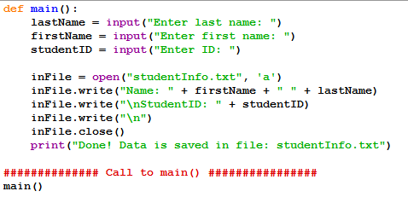

a. What output appears on the screen? “Done! Data is saved in file: student info.txt”

b. What does the program do? Makes a new file and adds The first and last name, and student Id it adds it to the file StudentInfo.txt if it already exists

c. Locate the file **studentInfo.txt** on your computer. The file is stored in the same folder as the program. What is stored in the file? First and last names and student IDs

d. Change the argument ‘a’ to ‘w’ in the call to the **open** function. What is the purpose of the “w” in the following line of code?

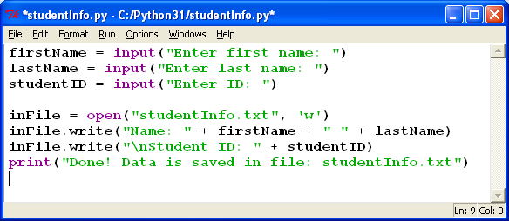

It wipes the file clean and then writes the entered information

e. Did you create the file: **studentInfo.txt** separately from the program code? no

f. Execute the program again using different input. Open the **studentInfo.txt** file. What is in the file? Is the data from the first program execution still there?

No W wipes the content that used to be saved in the file.

g. Change the ‘w’ to ‘a’ in the **open()** function. Execute the program again with different input. Examine the **studentInfo.txt** file. What did ‘a’ as an argument in the **open()** function do?

The A mean append which adds the new input to the file without altering the files original conetents

h. Notice the function – **write().** How many arguments does the write function have? How ever many required to write what you need. 1

i. How does the **write()** function know what file to write to? It knows because the file python opened prior to writing is studentinfo.text

j. What line of code closes the file? Where is the line of code positioned in the program?

inFile.Close its after the end of the write functions

k. Rewrite the program so that the user can enter three names during one execution of the program. You may need to change the order of some of the code.

def main():

inFile = open("studentInfo.txt", 'w')

x=0

for x in range(3):

lastName = input("\nEnter last name: ")

firstName = input("Enter first name: ")

studentID = input("Enter ID: ")

inFile.write("Name: " + firstName + " " + lastName)

inFile.write("\nStudentID: " + studentID)

inFile.write("\n\n")

x+1

inFile.close()

print("Done! Data is saved in file: studentInfo.txt")

main()

**Application Questions: Use the Python Interpreter to check your work**

1. Write a program that randomly generates 1000 numbers between 1 and 25 and writes the numbers to a file, one number per line.

import random

def main():

inFile = open("Nums.txt", 'w')

x=0

for x in range(1000):

inFile.write(str(random.randint(1,25)))

inFile.write("\n")

x+1

inFile.close()

print("Done! Data is saved in file: Nums.txt")

main()

2. Write a program that prompts the user for information for three students: name, student ID, number of credits earned. Store the information in a file.

def main():

inFile = open("studentInfo.txt", 'w')

x=0

for x in range(3):

lastName = input("Enter last name: ")

firstName = input("Enter first name: ")

studentID = input("Enter ID: ")

credit = input("How many credits have you earned so far?: ")

inFile = open("studentInfo.txt", 'a')

inFile.write("Name: " + firstName + " " + lastName)

inFile.write("\nStudentID: " + studentID)

inFile.write("\nCredits earned: "+credit)

inFile.write("\n\n")

x+1

inFile.close()

print("Done! Data is saved in file: studentInfo.txt")

main()